* Solve Josephus's Problem for 7 soldiers using JavaScript. (You can try to solve it with classes)
* Display in the console:
  + 1 Kills 2
  + 3 Kills 4
  + 5 Kills 6
  + 7 Kills 1
  + 3 Kills 5
  + 7 Kills 3
  + 7 Remains alive

**EXAM** Write a program that will solve simple sudoku (not only the example below!)

Start

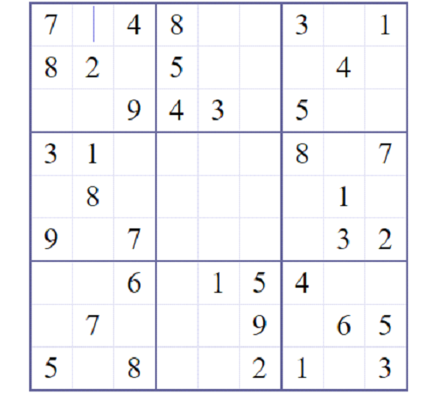

**Solution**

